Visit Report: Amtoli Upazila Health Complex, Barguna
Date of Visit: 25/08/22; Time: 8:45 AM.
Visitor: Md. Abdul Hakim Mazumdar, National Consultant (HEU),
Dr. Md. Emdadul Haque, National Consultant (HEU)
Md. Shamsur Rahman, Junior National Consultant (HEU) &
Dr. Nazmur Rahman Sajib, Junior National Consultant (HEU)

1. We arrived at 8:45 am in the health complex. But no medical officer except EMO was present in the health complex.
2. The infra-structure of this Upazila Health Complex is 50 bedded. The UHC is situated close to the high way. There are 7 unions under this UHC.
3. We met with the RMO and other Medical Officers, discuss with them about the overall situation of health complex. The post of Gynae and Anaesthesia consultant was vacant, so caesarean section is not performed.
4. We visited outdoor of the Upazila Health Complex of Amtoli. The outdoor was crowded with patients. We observed OPD, Emergency, labour room, pathology and pharmacy department. There are two medical technologist (Lab). The information display system was better than any other UHC of Barguna district, but there is no health education system existed there.
5. Cleanliness of the hospital premises and indoor was satisfactory. There is separate
operation theatre but not functioning.
6. There is no cycle stand close to the main gate. There are many motorcycles parked
within corridor.
7.The roof of the health complex is not clean. There are many bushes and unwanted hospital beds and other items on the roof.
8.There are many spaces in emergency, SSK Booth and Pharmacy can easily be established there.
9.There are many “Danbox” throughout the UHC, and advised for removing those immediately.
10. In 2021, OPD patient was 36,592 and indoor patient was 3,480; ANC 1st visit 541 and NVD was 65. Bed occupancy rate was 81% in 2021. As a whole, the institution is underutilized.
11. The UHC was awarded by “Health Ministered Award ” in 2015.

Health Profile of Amtoli UHC, Amtoli, Barguna
Total population: 244,438
Union: 7 Sub-centre: 2 FWC: 7 Community Clinic: 29
Human Resources: 50 Bedded Hospital:
Sl. | Designation | No. of Post | Present | Vacant
1. | UH&FPO | 1 | 1 | 0
2. | Junior Consultant | 11 | 0 | 11
3. | Medical Officer | 2 | 2 | 0
4. | Medical Officer (OSD) | 7 | 6 | 1
5. | Nurses | 30 | 30 | 0
6. | Mid wives | 4 | 4 | 0
7. | Medical Technologist (Lab) | 3 | 2 | 1
8. | MT EPI | 1 | 1 | 0
9. | Dental Technologist | 1 | 0 | 1
10. | MT (Radiology) | 1 | 1 | 0
11. | SACMO | 4 | 4
12. | Health Inspector (HI) | 2 | 0 | 2
13. | Assist. Health Inspector | 7 | 7
14. | Health Assistant | 21 | 19 | 2
15. | CHCP | 29 | 29
16 | Head Assistant | 1 | 0 | 1
18. | Accountant/Statistician | 2 | 1 | 1
19. | MLSS | 4 | 2 | 2
20. | Cleaner | 5 | 4 | 1
21. | FWA | 21 | 21 | 0
22. | Outsourcing: Cleaner, Cook, Guard, Ward boy, Aya. | 4 | 1 | 3

Status in HSS Score From Jan-July.
Name | Janu | Feb | Mar | April | May | June | July
Barguna D-Hospital | 03 | 07 | 19 | 22 | 21 | 16 | 19
Amtoli UHC | 319 | 200 | 255 | 298 | 207 | 368 | 353
Betagi UHC | 306 | 314 | 304 | 332 | 340 | 337 | 341
Bamna UHC | 221 | 162 | 290 | 230 | 279 | 277 | 279
Pathorghata UHC | 209 | 291 | 347 | 258 | 248 | 270 | 385
Taltoli UHC | - | - | - | - | - | - | -

Status of Building Blocks of C-J Model in the Amtoli UHC:
Sl | Criteria of C-J Model | Best | Good | Weak
 | Cycle stand close to the main gate |  |  | √
 | Health Education |  | √
 | Cleanliness & beautification | √
 | Separation of patients in out door & indoor |  |  | √
 | Blood doner list with 24/7 B.T facility |  | √
 | Birth- death recording |  |  | √
 | Reception Desk |  |  | √
 | Developed Emergency Dept. |  | √
 | 5S –KAIZEN implementation. |  | √
 | Community Participation. |  | √
 | Hospital activities Display |  | √
 | Corner based service. |  | √
 | Cash counter for receiving Govt money. |  |  | √
 | Devolped maternal health/labour word. |  |  | √
 | Devolped paediatric health |  |  | √
 | Position in HSS score  (Best= <100; Good= 101-200; Weak= >200) |  |  | √
 | Power point Presentation &Video on UHC |  | √
 | Knowledge about 8th Five Year plan & SDG. |  |  | √
 | Zero-Tollarance on corruption |  | √

Recommendations:
- Utilization rate ofn the UHC must be improved and office time must be maintained.
- For better office management, the post of Head Assistant and Statistician is very important. Both the post is lying vacant. It should be filled up immediately.
- Cleanliness and beautification is satisfactiry. The local Powroshova must take part in waste management.
- There is no OT room in the health complex.
- Labor room is well functioning.
- Condemetion Board should work to destory all unwanted items.
- All the vacant posts of 4th class should be fulfilled immediataely.
- Medical Technologist (Dental) is necessary for dental dept.
- Replication of C-J model will help in development of the quality of care and it should be followed properly.
- All the post of consultants especially Gynae consultant and Anesthesia should be filled up immediately .
- Radiogical service is not functioning.Vaccant post of radiographer shoul be fulfilled.
- There should be a Complains and Suggestion box in front of UH&FPO room.
- The roof of the health complex building should be clean.
- There is availability of safe drinking water.
- All the “Danbox” of the UHC, should be remove.

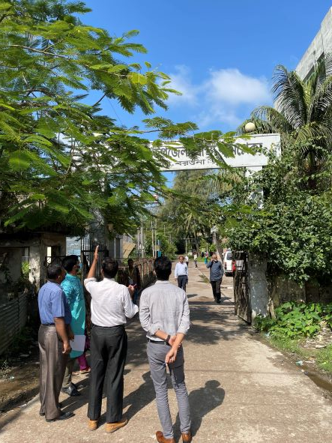
Fig-2: Front Gate of the Amtoli UHC

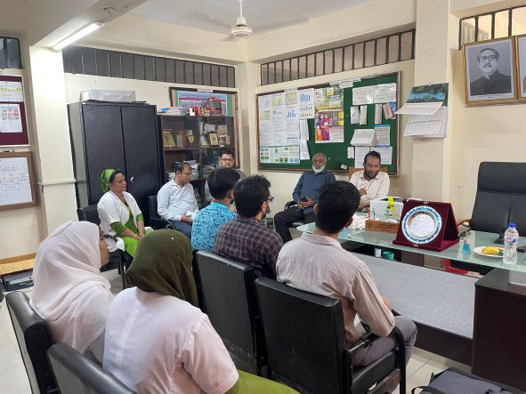

Fig-3: Meeting with the RMO and Medical Officers

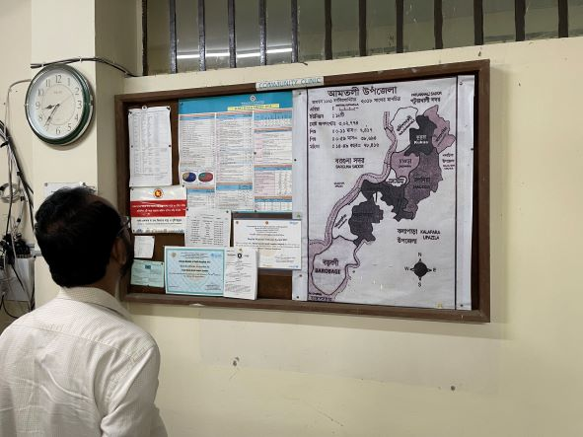

Fig-4: Improved Display System but not updated

